Manage Reports enables you to select a study and subject and review the adverse event reports submitted for a subject in a particular study. You can also perform the following tasks with the adverse event reports:
- Export an adverse event report.
- Withdraw an adverse event report.
- View the contents of a submitted adverse event report.
- Amend a submitted adverse event report.
- Notify caBIG Patient Study Calendar of an Adverse Event - caBIG Clinical Trials Suite Users
Note: All required fields in caAERS have a red asterisk next to them. This means you must complete the field to save and continue to the next page. Based on the user role assigned to you by the caBIG caAERS Administrator and how the product was configured, you may not have access to all the fields and pages described in this topic.

Contents
[hide]
- 1 Selecting a Study and a Subject
- 2 Reviewing Adverse Event Reports
  - 2.1 Exporting an Adverse Event Report
  - 2.2 Withdrawing an Adverse Event Report
  - 2.3 Viewing the Contents of a Submitted Adverse Event Report
  - 2.4 Amending a Submitted Adverse Event Report
  - 2.5 Notifying caBIG PSC - for caBIG Clinical Trials Suite Users Only

Selecting a Study and a Subject
To access the adverse event reports for a study and subject
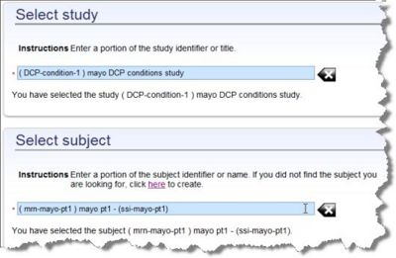
- Click the Adverse Events tab.
- Click the Manage Reports task.
- Find the Study and Subject combination for which you want to review the adverse event reports:
  - Enter a study or portion of a study title. Select the study from the list.
  - Enter a subject name or portion of a name. Select a subject from the list. If the subject name is not listed, you can add another subject by clicking on here in the instructions. See Adding a Subject.
- Click Continue to display the adverse event report(s) for each course of treatment. The Manage Reports page lists the courses associated with the selected study and subject.

Reviewing Adverse Event Reports
The Manage Reports page (see Selecting a Study and a Subject and follow the procedure to display this page) enables you to perform various tasks involving expedited adverse event reports.
To manage adverse event reports
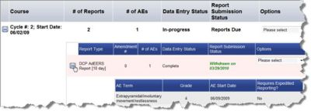
- For each course of treatment, the following information is listed:
  - Course name is the name identifying the course of treatment.
  - Number of Reports indicates the number of adverse event reports generated for the course of treatment.
  - Number of AEs is the number of adverse events entered for this course of treatment.
  - Data Entry Status indicates whether the information needed to submit the adverse event reports is Complete. If any one of the reports are still In-Progress, the status for the course is In-Progress.
  - Report Submission Status indicates whether there is a report for this course that is Report Due, Withdrawn, days overdue, or Complete.
  - To edit the adverse events within a course of treatment, from the Options column, select Edit Adverse Events. The message Are you sure you want to perform this action? appears.
    - Click Yes to edit the study, subject, course adverse events (see Reporting Adverse Events).
    - Click No to return.
- To display the adverse event reports for the course of treatment, click the plus sign to the left of the course row. The information expands to list the expedited report(s) associated with the course of treatment. To edit the adverse event terms associated with the report, click the report name. The Reporter page opens. See Adding the Person Who Reported the Adverse Event the first page in the Enter AE flow. Note that if the report is already submitted and complete, you cannot edit the adverse events. The following information is listed for each report.
  - Report Type is the name of the report
  - Amendment is how many times the report was changed and submitted.
  - Number of AEs are the number of adverse events associated with the report.
  - Data Entry Status indicates whether the adverse event report is In-Progress and has not been submitted or is Complete.
  - Report Submission Status indicates whether the adverse event report is Complete, Withdrawn, or days overdue.
  - The Options column enables you to:
    - Export to an adverse event report to a file, see Exporting an Adverse Event Report. The available file types are based on the Entering Study Details, Expedited Report Formats selection.
    - Withdraw a report from submission, see Withdrawing an Adverse Event Report.
    - View the contents of a submitted adverse event report, see Viewing the Submitted Adverse Event Report.
    - Amend a submitted adverse event report, see Amending a Submitted Adverse Event Report.
    - Notify PSC is for caBIG Clinical Trials Suite users only. This option enables you to alert the caBIG Patient Study Calendar that an adverse event occurred that might warrant a change in the patient's schedule. For more information, see Notifying PSC.
- Click the plus sign to the left of the adverse event report. The adverse event terms associated with the report are listed with the following information:
  - AE Term identifies the subject's adverse event.
  - Grade identifies the seriousness of the adverse event.
  - AE Start Date identifies when the subject started experiencing the adverse event.
  - Requires Expedited Reporting indicates whether expedited reporting is necessary.

Exporting an Adverse Event Report
With the Adverse Events, Manage Reports option you can export an adverse event report to a format useful for an organization, such as DCP or CIOMS. The formats to which you can export are originally specified in Entering Details about the Study with Expedited Report Formats.
To export an adverse event report to an output file
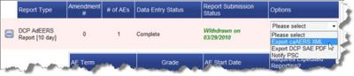
- Follow the Selecting a Study and Subject procedure to select a study and subject for which to display adverse events. The Manage Report page opens.
- When the list of courses displays, click study calendar link at the top of the page. The caBIG Patient Study Calendar opens in a new window with the adverse events added to the subject's calendar.

Withdrawing an Adverse Event Report
With the Adverse Events, Manage Reports option, you can withdraw a report, so that it is not submitted.
To withdraw an adverse event report from submission
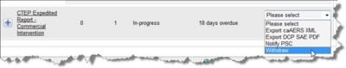
- Follow the Selecting a Study and Subject procedure to select a study and subject for which to display adverse events. The Manage Report page opens.
- Click the plus sign next to the course to display the reports associated with the course of treatment.
- In the row of the report to be withdrawn, click the Options column option and select Withdraw.
- The Report Submission Status changes to Withdrawn.

Viewing the Contents of a Submitted Adverse Event Report
With the Adverse Events, Manage Reports option, you can display the contents of a submitted adverse event report.
To access a submitted or amended and submitted report
- Follow the Selecting a Study and Subject procedure to select a study and subject for which to display adverse events. The Manage Report page opens.
- When the list of courses displays, click the viewer server response link under Report Submission Status. A popup window opens listing a report number, a ticket number, and the URL you can click to view the report.

Amending a Submitted Adverse Event Report
Sometimes after an expedited report is submitted, the original adverse event reappears during the same course/cycle but is more severe. In that case, you need to amend the original expedited report and resubmit it. If the same adverse event reappears later in the course but is not as severe and the subject is recovering, then you do not need to resubmit the expedited report.
Note: You can amend a submitted expedited report through the Adverse Events, Enter AEs option or through the Adverse Events, Manage Reports option. Changes made to adverse events in either the Enter AEs or the Managed Reports area are reflected in both places. A specific reason to amend from Manage Reports is if you want to remove an observed or solicited adverse event from the expedited report but not from the evaluation period.
To amend a submitted expedited report through the Enter AE flow:
- Click the Adverse Events tab and select Enter AEs.
- Select a study and a subject associated with the expedited report that you want to edit. Click Continue.
- On the next page, select the appropriate Evaluation Period. A green R icon appears next to adverse events included in expedited reports with a Submitted status. Click Submit.
- To update adverse event reports, see Editing Adverse Events.
  - If you delete an adverse event with a green R icon, a pop-up message opens. Read the instructions in the window and click Amend. The green icons disappear from all adverse events that associated with the report that you amended.
  - If you click Don't Amend, you must return to the Adverse Events page and manually set the information that you edited back to the previous settings.
- On the Review and Report page, click Continue. The status of the amended report will have changed from Submitted/Data Complete to Pending, and the Revision Number will have increased.
- If you deleted an adverse event, you must go to task 2. Enter AEs to verify the primary adverse event has a start date associated to it. If there is no start date for the primary adverse event, resubmission of the amended report will fail.
- Click Edit next to the report that you amended to go to the expedited report and complete the amendment process.
To amend a submitted expedited report through Manage Reports
- Click the Adverse Events tab and select Manage AEs.
- Enter the Subject and Study combination that has the expedited report you want to edit associated with it, and click Continue.
- Expand the Evaluation Period that has the expedited report you want to amend.
- From the Options column, click Amend. The expedited report opens.
- Make changes as needed to update the Data Entry Status to from Submitted/Data Complete to Pending, and update the Revision Number to reflect a new version.

Notifying caBIG PSC - for caBIG Clinical Trials Suite Users Only
With the Adverse Events, Manage Reports option, you can determine whether an adverse event entered into caAERS may require review of the patient's schedule or treatment. There is a link to the caBIG Patient Study Calendar (PSC) application where you can review a subject's schedule. Based on the review, you can then alert or notify PSC, so that a caBIG PSC user will determine whether a changed is needed. For more information about caAERS and caBIG PSC interactions, see caBIG Clinical Trials Suite User's Guide, Chapter 8.
To review the patient's schedule
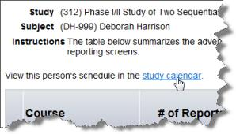
- Follow the select a study and subject procedure to select a study and subject for which to display adverse events. The Manage Reports page opens.
- Click study calendar link at the top of the Manage Reports page.
- The caBIG Patient Study Calendar opens in a new window with the adverse events added to the subject's calendar in red.
To alert caBIG PSC of an adverse event
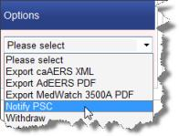
- Follow the Selecting a Study and Subject procedure to select a study and subject for which to display adverse events. The Manage Report page opens.
- Click the plus sign next to the course to display the reports associated with the course of treatment.
- In the row of the report for which you want to notify caBIG PSC, click the Options column option and select Notify PSC.

